Spring MVC / Spring boot

for mac

1. Install Gradle

First install brew

Link: <https://brew.sh/>

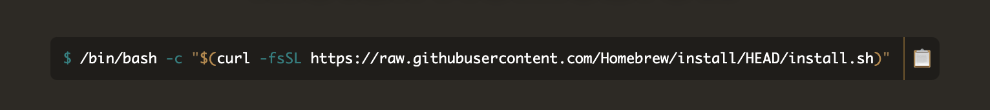

Second use this cm for install Gradle



Success

1. Install Maven



Success